FACE RECOGNITION

**OBJECTIVE:**

Development of a model for face recognition. The model will compare the images and gives output whether they are similar or not.

**TECHNOLOGY PACK:**

* PYTHON
* JUPYTER NOTEBOOK
* OPENCV-PYTHON
* CV2
* FACE-RECOGNITION
* DLIB

**WORKFLOW:**

* **Firstly we have to import the required modules**
* **Download or upload the images that you need to compare**
* **The processes goes on once we give the path of the images to the system**
* **And finally we will get the output either true or false**
* **If both the images matched successfully we will get the output as true or else false**

**CODE:**

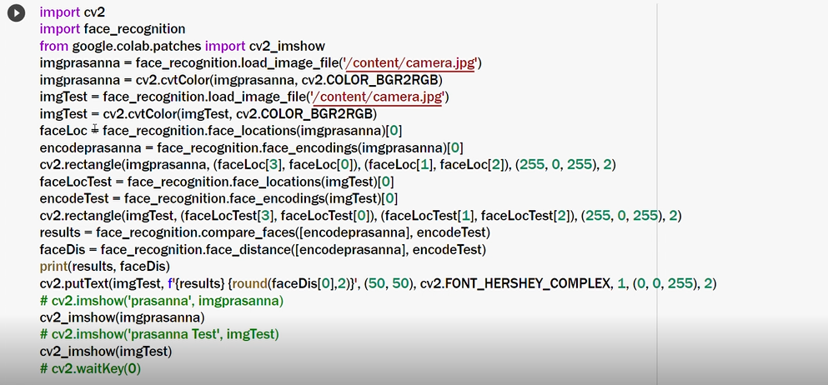

**EXPECTED OUTPUT:**

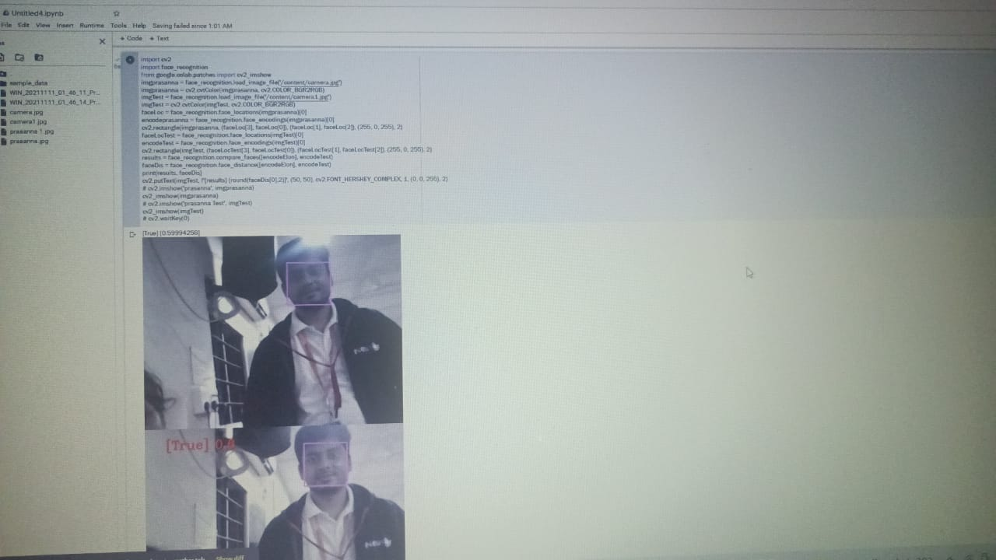

**ADVANTAGES:**

* **We can easily detect the person in a blurred or uncleared images.**

**CONCLUSION:**

**Facial detection is influenced by clarity of the image, coloured or black and white image. It can only support frontal detection of images.**